**HUNDREDS NUMBER CHART & CARDS**

|  |  |
| --- | --- |
| **Manipulative** | **Hundreds Number Chart & Cards** |
| **Materials** | A4 White Paper |
| Dark colored (plain) Panaflex/ thick fabric, measuring 36 by 36 inches |
| Thick, Transparent Plastic Sheet measuring 36 by 36 inches |
| Thread |
| Erasable Marker |
| Liquid Glue/ Tape |
| Scissors |
| **Details of 1 set** | 1 chart contains 11 x 11 clear plastic pockets  1-100 number cards |

**Guidelines:**

**Hundreds Chart**

1. Draw lines (using erasable marker) on the plastic sheet to indicate where it will be stitched onto the panaflex/ fabric to make pockets. There should be 12 horizontal and 12 vertical lines to fit a total of 121 pockets (11 in each row and 11 in each column). The lines should be drawn at least 3 inches apart vertically and 3 inches apart horizontally (to be able to fit 2.5 by 2.5 inches number cards in each pocket).
2. Stitch the plastic and panaflex/ fabric together, along the outermost lines first and then stitch over the remaining lines. Do not stitch along the topmost horizontal line.
3. After plastic has been fastened to the panaflex/ fabric, cut the plastic sheet open 0.5 inches below each horizontal line, to create pockets for the number cards to be inserted.
4. Turn the fabric around and stitch the top edges to create a neat border for the hundreds chart.

**1-100 Number Cards**

1. Print designs on white A4 paper.
2. Hard laminate each printed sheet.
3. Cut out each number card from this laminated sheet (each card should be 2.5 x 2.5 inches).
4. Secure the edges of each card with liquid glue or tape to ensure the lamination does not come off/ peel apart.

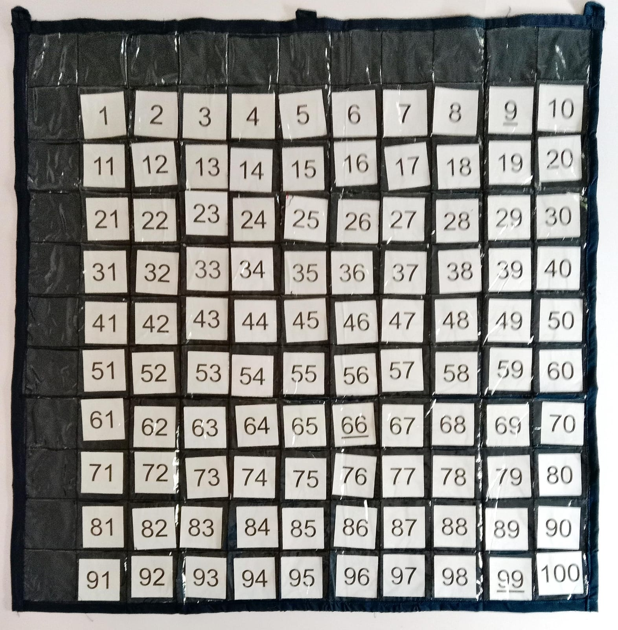

|  |  |  |  |  |
| --- | --- | --- | --- | --- |
| 1 | 2 | | 3 | 4 |
| 5 | 6 | | 7 | 8 |
| 9 | 10 | | 11 | 12 |
| 13 | 14 | | 15 | 16 |
| 17 | 18 | | 19 | 20 |
| 21 | 22 | | 23 | 24 |
| 25 | 26 | | 27 | 28 |
| 29 | 30 | | 31 | 32 |
| 33 | 34 | | 35 | 36 |
| 37 | 38 | | 39 | 40 |
| 41 | 42 | | 43 | 44 |
| 45 | 46 | | 47 | 48 |
| 49 | 50 | | 51 | 52 |
| 53 | 54 | | 55 | 56 |
| 57 | 58 | | 59 | 60 |
| 61 | 62 | | 63 | 64 |
| 65 | 66 | | 67 | 68 |
| 69 | 70 | | 71 | 72 |
| 73 | 74 | | 75 | 76 |
| 77 | 78 | | 79 | 80 |
| 81 | 82 | | 83 | 84 |
| 85 | 86 | | 87 | 88 |
| 89 | 90 | | 91 | 92 |
| 93 | 94 | | 95 | 96 |
| 97 | 98 | | 99 |  |
| 100 | |