**NUMBER CHART CARDS (FOR DIVISION)**

|  |  |
| --- | --- |
| **Manipulative** | **Number Chart Division Cards** (to be used with the 100s chart containing 11 x 11 clear plastic pockets) |
| **Materials** | A4 White Paper |
| Liquid Glue/ Tape |
| Lamination |
| Scissors |
| **Details of 1 set** | 100 number cards  2 sets of 1-10 cards  1 card each for operation sign of × and ÷ |

**Guidelines:**

**1-10 Number Cards + Operation Symbol Cards**

1. Print designs on colored A4 paper.
2. Hard laminate each printed sheet.
3. Cut out each number card from this laminated sheet.
4. Secure the edges of each card with liquid glue or tape to ensure the lamination does not come off/ peel apart.

**Number Cards for Division**

1. Print designs on white A4 paper.
2. Hard laminate each printed sheet.
3. Cut out each number card from this laminated sheet (each card should be 2.5 x 2.5 inches).
4. Secure the edges of each card with liquid glue or tape to ensure the lamination does not come off/ peel apart.

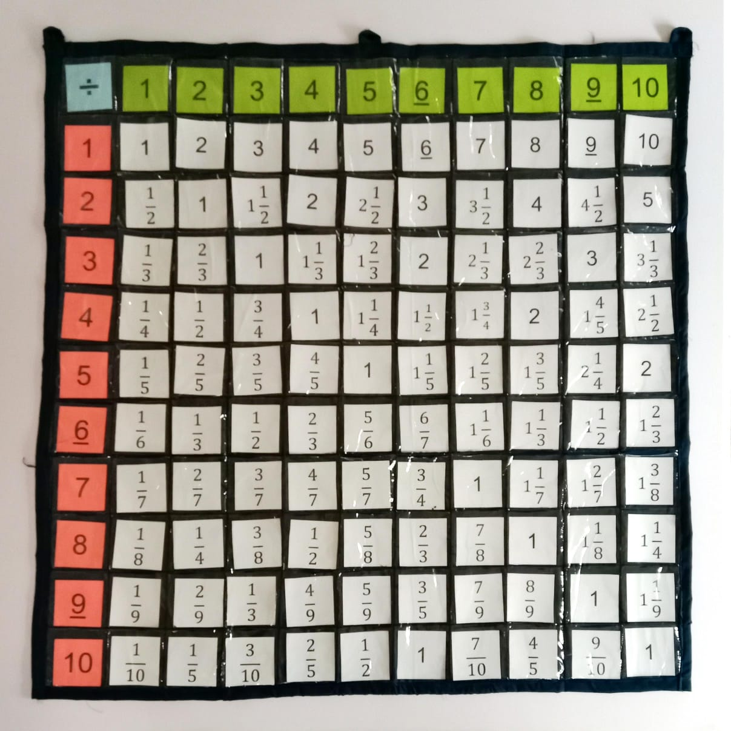

|  |  |  |  |
| --- | --- | --- | --- |
| 1 | 2 | 3 | 4 |
| 5 | 6 | 7 | 8 |
| 9 | 10 | $$\frac{1}{2}$$ | $$\frac{1}{3}$$ |
| $$\frac{1}{4}$$ | $$\frac{1}{5}$$ | $$\frac{1}{6}$$ | $$\frac{1}{7}$$ |
| $$\frac{1}{8}$$ | $$\frac{1}{9}$$ | $$\frac{1}{10}$$ | 1 |
| $$\frac{2}{3}$$ | $$\frac{1}{2}$$ | $$\frac{2}{5}$$ | $$\frac{1}{3}$$ |
| $$\frac{2}{7}$$ | $$\frac{1}{4}$$ | $$\frac{2}{9}$$ | $$\frac{1}{5}$$ |
| $1\frac{1}{2}$ | 1 | $$\frac{3}{4}$$ | $$\frac{3}{5}$$ |
| $$\frac{1}{2}$$ | $$\frac{3}{7}$$ | $$\frac{3}{8}$$ | $$\frac{1}{3}$$ |
| $$\frac{3}{10}$$ | 2 | $$1\frac{1}{3}$$ | 1 |
| $$\frac{4}{5}$$ | $$\frac{2}{3}$$ | $$\frac{4}{7}$$ | $$\frac{1}{2}$$ |
| $$\frac{4}{9}$$ | $$\frac{2}{5}$$ | $$2\frac{1}{2}$$ | $$1\frac{2}{3}$$ |
| $$1\frac{1}{4}$$ | 1 | $$\frac{5}{6}$$ | $$\frac{5}{7}$$ |
| $$\frac{5}{8}$$ | $\frac{5}{9}$ | 1 | $$\frac{1}{2}$$ |
| 3 | 2 | $$1\frac{1}{2}$$ | $$1\frac{1}{5}$$ |
| 1 | $$\frac{6}{7}$$ | $$\frac{3}{4}$$ | $$\frac{2}{3}$$ |
| $$\frac{3}{5}$$ | $$3\frac{1}{2}$$ | $$2\frac{1}{3}$$ | $1\frac{3}{4}$ |
| $$1\frac{2}{5}$$ | $$1\frac{1}{6}$$ | $$\frac{7}{8}$$ | $$\frac{7}{9}$$ |
| $$\frac{7}{10}$$ | 4 | $$2\frac{2}{3}$$ | 2 |
| $$1\frac{3}{5}$$ | $$1\frac{1}{3}$$ | $$1\frac{1}{7}$$ | 1 |
| $$\frac{8}{9}$$ | $$\frac{4}{5}$$ | $$4\frac{1}{2}$$ | 3 |
| $$2\frac{1}{4}$$ | $$1\frac{4}{5}$$ | $$1\frac{1}{2}$$ | $$1\frac{2}{7}$$ |
| $$1\frac{1}{8}$$ | 1 | $$\frac{9}{10}$$ | 5 |
| $$3\frac{1}{3}$$ | $$2\frac{1}{2}$$ | 2 | $$1\frac{2}{3}$$ |
| $$1\frac{3}{8}$$ | $1\frac{1}{4}$ | $$1\frac{1}{9}$$ | 1 |

|  |  |  |  |
| --- | --- | --- | --- |
| 1 | 2 | 3 | 4 |
| 5 | 6 | 7 | 8 |
| 9 | 10 | 1 | 2 |
| 3 | 4 | 5 | 6 |
| 7 | 8 | 9 | 10 |
| ÷ | × |  |  |