Construction Guide for Base 10 Blocks (ones, tens, hundreds, thousands)
Manipulative | Base 10 Blocks
Materials | Green legal paper
 | Scissors, Glue and Tape
 | Clear plastic sheets
 | - grams Card sheets
 | Cardboard, Styrofoam, newspaper, self-drying clay, rice, sand etc. to fill the blocks
Details of 1 set | 20 units (ones), 20 rods (tens), 20 flats (hundreds), 2 cubes (thousands)

Guidelines:
Units, Rods, Flats
- Print the design files below on green legal paper.
- Cut out each block along its outer edges.
- Fold each block as shown at: blocks (youtube.com)
- Remember to fill each block with a suitable filler material such as cardboard, Styrofoam, newspaper, self-drying clay, rice, sand etc.
- Tape the blocks to secure.

Cubes (thousands)
Follow the construction steps shown at: https://youtu.be/3W8VP5kwFzg?si=_yv25Ai9AaJkooR4
- You may fill the cube with any other sturdy material such as cardboard etc to ensure that it holds its shape
- After sealing the cube, wrap it in plastic sheet and secure the sheet with tape.

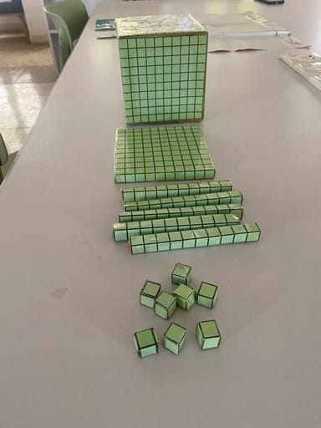 | 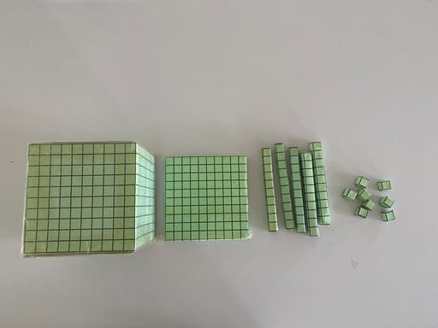

HUNDREDS FLAT

THOUSANDS CUBE (to be printed 3 times (6 square faces) to make one complete cube)

