**Construction Guide for Division Dominos**

|  |  |
| --- | --- |
| **Manipulative** | **Division Dominos** |
| **Materials** | Cardboard/ Carton sheet |
| Four colored A4 paper (same color) |
| Glue |
| Tape |
| **Details of 1 set** | 28 domino tiles |

**Guidelines:**

1. Cut cardboard into pieces of 4 x 2 inches.
2. Print designs for division dominos on A4 paper and cut each domino tile along the dotted lines.
3. Glue each tile onto the cardboard pieces.
4. Apply tape over the glued tiles.

|  |  |  |  |
| --- | --- | --- | --- |
| |  | | --- | | **48** | | **گروہ 8** | **ہرگروہ میں 6 چیزیں** |
|  | **36** | |  | | --- | | **40** | |
| **48÷8= __** | **48÷6= __** |  |
| |  | | --- | | **40** | |  | |  | | --- | | **30** | |
| **گروہ 4** |  |  |

|  |  |  |  |  |  |
| --- | --- | --- | --- | --- | --- |
| |  | | --- | | **24÷4= __** | | |  | | --- | | **36÷4= __** | | |  | | --- | | **36÷9= __** | |
| **24** | **گروہ 9** | |  |  | | --- | --- | | |  | | --- | | **40÷5= __** | | |
| **ہرگروہ میں 4 چیزیں** | |  | | --- | | **گروہ 4** | | **36** |
| |  | | --- | | **گروہ 4** | | |  | | --- | | **30÷6= __** | | |  | | --- | | **گروہ 10** | |
| |  | | --- | | ***ہرگروہ میں 4 چیزیں*** | | **40÷8= __** |  |

|  |  |  |  |  |
| --- | --- | --- | --- | --- |
| |  | | --- | | **36÷6= __** | | |  | | --- | | **36÷6= __** | |  |
| **ہرگروہ میں 10 چیزیں** | |  | | --- | | **30÷5= __** | | **ہرگروہ میں 3 چیزیں** |
| **ہرگروہ میں 6 چیزیں** | **ہرگروہ میں 5 چیزیں** | **گروہ 8** |
| |  | | --- | | **24÷4= __** | | |  | | --- | | **40÷4= __** | | |  | | --- | | **ہرگروہ میں 6 چیزیں** | |
| |  | | --- | | ***ہرگروہ میں 6 چیزیں*** | | **24÷6= __** |  |
| **40** | **گروہ 8** | |  | | --- | | **40÷10=__** | |
| **30÷10= __** | **ہرگروہ میں 6 چیزیں** | |  |  | | --- | --- | | |  | | --- | | **گروہ 5** | | |
|  | **24** | **30** |
| |  | | --- | | **30÷3= __** | | |  | | --- | | **گروہ 4** | |  |
| |  | | --- | | ***30*** | |  |

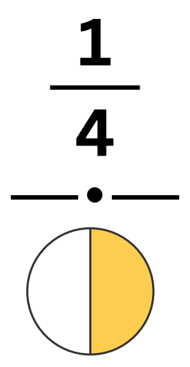

**12**



**7**



**6**



**5 × __ = 20**

**7 × __ = 42**



**3**

**36 ÷ 4**