**Construction Guide for Division Mats and Cards**

|  |  |
| --- | --- |
| **Manipulative** | **Division Mats and Cards** |
| **Materials** | Four A3 papers for printing mats |
| Six A4 papers for printing cards |
| Scissors, Liquid Glue and Tape |
| Lamination |
| Clear plastic sheets |
| 260 grams Card sheets |
| **Details of 1 set** | 4 Square mat cards and  36 answer cards |

**Guidelines:**

1. Print the cards on A4 paper, cut and laminate them. Secure the edges with liquid glue or tape to ensure the lamination does not come off/ peel apart.
2. Print the mats on A3 paper and cut along the outer edge.
3. Paste the mat onto card sheets.
4. Wrap the mats in plastic sheet and secure with tape.

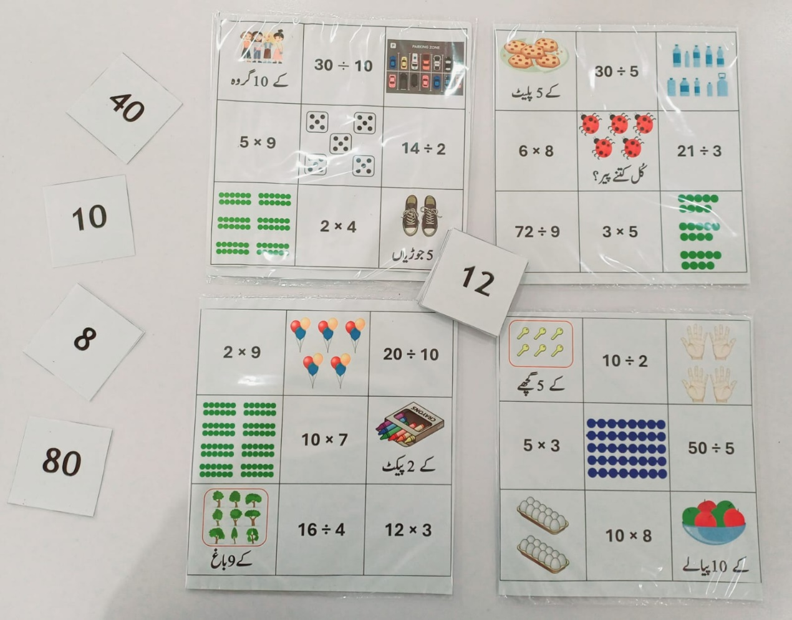

|  |  |  |
| --- | --- | --- |
| 121 Best Four Friends Girls Stock Vectors and Vector Art | Shutterstock  **گروہ10 کے** | **30 10** | Premium Vector | Vector illustration city parking lot, public car-park with  a set of different cars |
| **5 × 9** |  | **14 ÷ 2** |
|  | **2 × 4** | **جوڑیاں5 کی** |

|  |  |  |
| --- | --- | --- |
| **2 × 9** | Two Different Arrangements Of Three Party Balloons Tied, 60% OFFTwo Different Arrangements Of Three Party Balloons Tied, 60% OFFTwo Different Arrangements Of Three Party Balloons Tied, 60% OFF  Two Different Arrangements Of Three Party Balloons Tied, 60% OFFTwo Different Arrangements Of Three Party Balloons Tied, 60% OFF | **20 ÷ 10** |
|  | **10 × 7** | **پیکٹ2 کے** |
| Nine Trees Stock Illustrations – 188 Nine Trees Stock Illustrations,  Vectors & Clipart - Dreamstime  **باغ 9 کے** | **16 ÷ 4** | **12 × 3** |

|  |  |  |
| --- | --- | --- |
| Chocolate Chip Cookies | Restaurant City Wiki | Fandom **پلیٹ 5 کے** | **30 ÷ 5** |  |
| **6 × 8** | Over 200 Free Ladybug Vectors - Pixabay - Pixabay Over 200 Free Ladybug Vectors - Pixabay - Pixabay Over 200 Free Ladybug Vectors - Pixabay - Pixabay  Over 200 Free Ladybug Vectors - Pixabay - Pixabay Over 200 Free Ladybug Vectors - Pixabay - Pixabay  **کُل کتنے پیر؟** | **21 ÷ 3** |
| **72 ÷ 9** | **3 × 5** |  |

|  |  |  |
| --- | --- | --- |
| A yellow key with black outline  Description automatically generatedA yellow key with black outline  Description automatically generated  A yellow key with black outline  Description automatically generatedA yellow key with black outline  Description automatically generated  **گچھے5 کے** | **10 ÷ 2** | Hands. Stock Vector by ©Leonardi 6529281  Hands. Stock Vector by ©Leonardi 6529281 |
| **5 × 3** |  | **50 ÷ 5** |
| Carton 12 Brown Eggs Stock Vector (Royalty Free) 201249878 | Shutterstock  Carton 12 Brown Eggs Stock Vector (Royalty Free) 201249878 | Shutterstock | **10 × 8** | Premium Vector | Red and green apples in a plate. **پیالے10 کے** |

|  |  |
| --- | --- |
| **40** | **3** |
| **14** | **45** |
| **25** | **7** |
| **72** | **8** |
| **10** | **18** |
| **15** | **2** |
| **96** | **70** |
| **12** | **81** |
| **4** | **36** |
| **25** | **6** |
| **10** | **48** |
| **30** | **7** |
| **8** | **15** |
| **27** | **30** |
| **5** | **20** |
| **15** | **40** |
| **10** | **12** |
| **80** | **60** |