**Construction Guide for Fraction Tiles**

|  |  |
| --- | --- |
| **Manipulative** | **Fraction Tiles** |
| **Materials** | A4 Paper in 9 different colors |
| Scissors and Glue |
| Tape |
| Cardboard/ Carton sheet |
| **Details of 1 set** | 51 pieces (1 whole, 2 halves, 3 thirds, 4 fourths, 5 fifths, 6 sixths, 8 eighths, 10 tenths, 12 twelfths) |

**Guidelines:**

1. Print design file for fraction tiles on A4 paper. Use different colored sheets for each fractional part.
2. Paste the printed designs onto cardboard sheets using glue.
3. Cut out each fraction tile.
4. Cover each tile with tape.

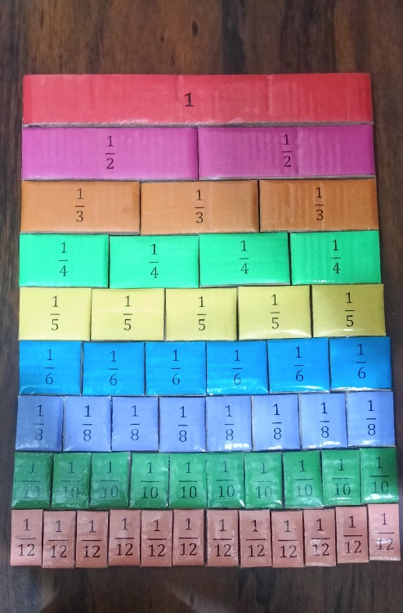

|  |
| --- |
| **1** |
| **1** |
| **1** |
| **1** |
| **1** |

|  |  |
| --- | --- |
|  |  |
|  |  |
|  |  |
|  |  |
|  |  |

|  |  |  |
| --- | --- | --- |
|  |  |  |
|  |  |  |
|  |  |  |
|  |  |  |
|  |  |  |

|  |  |  |  |
| --- | --- | --- | --- |
|  |  |  |  |
|  |  |  |  |
|  |  |  |  |
|  |  |  |  |
|  |  |  |  |

|  |  |  |  |  |
| --- | --- | --- | --- | --- |
|  |  |  |  |  |
|  |  |  |  |  |
|  |  |  |  |  |
|  |  |  |  |  |
|  |  |  |  |  |

|  |  |  |  |  |  |
| --- | --- | --- | --- | --- | --- |
|  |  |  |  |  |  |
|  |  |  |  |  |  |
|  |  |  |  |  |  |
|  |  |  |  |  |  |
|  |  |  |  |  |  |

|  |  |  |  |  |  |  |  |
| --- | --- | --- | --- | --- | --- | --- | --- |
|  |  |  |  |  |  |  |  |
|  |  |  |  |  |  |  |  |
|  |  |  |  |  |  |  |  |
|  |  |  |  |  |  |  |  |
|  |  |  |  |  |  |  |  |

|  |  |  |  |  |  |  |  |  |  |
| --- | --- | --- | --- | --- | --- | --- | --- | --- | --- |
|  |  |  |  |  |  |  |  |  |  |
|  |  |  |  |  |  |  |  |  |  |
|  |  |  |  |  |  |  |  |  |  |
|  |  |  |  |  |  |  |  |  |  |
|  |  |  |  |  |  |  |  |  |  |

|  |  |  |  |  |  |  |  |  |  |  |  |
| --- | --- | --- | --- | --- | --- | --- | --- | --- | --- | --- | --- |
|  |  |  |  |  |  |  |  |  |  |  |  |
|  |  |  |  |  |  |  |  |  |  |  |  |
|  |  |  |  |  |  |  |  |  |  |  |  |
|  |  |  |  |  |  |  |  |  |  |  |  |
|  |  |  |  |  |  |  |  |  |  |  |  |