**PLACE VALUE CARDS**

|  |  |
| --- | --- |
| **Manipulative** | **Place Value Cards** |
| **Materials** | Colored A4 Paper |
| Scissors |
| Glue |
| Tape |
| 260 grams Card sheets |
| **Details of 1 set** | 1 set of 63 cards (9 cards EACH for numbers 1-9, 10-90, 100-900, 1,000-9,000, 10,000-90,000, 100,000-900,000 , 1,000,000-9,000,000) |

**Guidelines**

1. Print designs on colored A4 sheets, using a different color for each place value (for e.g. pink for tens, green for hundreds etc.).
2. Paste the printed designs onto card sheets.
3. Cut out the individual place value cards along the dotted lines.
4. Tape the pasted designs on both sides or laminate.

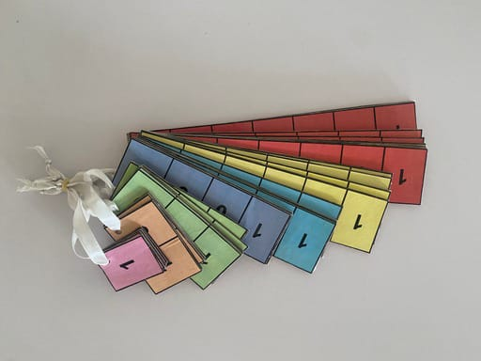

|  |  |  |  |  |  |  |
| --- | --- | --- | --- | --- | --- | --- |
| 1 , | 0 | 0 | 0 , | 0 | 0 | 0 |
| 2 , | 0 | 0 | 0 , | 0 | 0 | 0 |
| 3 , | 0 | 0 | 0 , | 0 | 0 | 0 |
| 4 , | 0 | 0 | 0 , | 0 | 0 | 0 |
| 5 , | 0 | 0 | 0 , | 0 | 0 | 0 |
| 6 , | 0 | 0 | 0 , | 0 | 0 | 0 |
| 7 , | 0 | 0 | 0 , | 0 | 0 | 0 |
| 8 , | 0 | 0 | 0 , | 0 | 0 | 0 |
| 9 , | 0 | 0 | 0 , | 0 | 0 | 0 |

|  |  |  |  |  |  |
| --- | --- | --- | --- | --- | --- |
| 1 | 0 | 0 , | 0 | 0 | 0 |
| 2 | 0 | 0 , | 0 | 0 | 0 |
| 3 | 0 | 0 , | 0 | 0 | 0 |
| 4 | 0 | 0 , | 0 | 0 | 0 |
| 5 | 0 | 0 , | 0 | 0 | 0 |
| 6 | 0 | 0 , | 0 | 0 | 0 |
| 7 | 0 | 0 , | 0 | 0 | 0 |
| 8 | 0 | 0 , | 0 | 0 | 0 |
| 9 | 0 | 0 , | 0 | 0 | 0 |

|  |  |  |  |  |
| --- | --- | --- | --- | --- |
| 1 | 0 , | 0 | 0 | 0 |
| 2 | 0 , | 0 | 0 | 0 |
| 3 | 0 , | 0 | 0 | 0 |
| 4 | 0 , | 0 | 0 | 0 |
| 5 | 0 , | 0 | 0 | 0 |
| 6 | 0 , | 0 | 0 | 0 |
| 7 | 0 , | 0 | 0 | 0 |
| 8 | 0 , | 0 | 0 | 0 |
| 9 | 0 , | 0 | 0 | 0 |

|  |  |  |  |
| --- | --- | --- | --- |
| 1 , | 0 | 0 | 0 |
| 2 , | 0 | 0 | 0 |
| 3 , | 0 | 0 | 0 |
| 4 , | 0 | 0 | 0 |
| 5 , | 0 | 0 | 0 |
| 6 , | 0 | 0 | 0 |
| 7 , | 0 | 0 | 0 |
| 8 , | 0 | 0 | 0 |
| 9 , | 0 | 0 | 0 |

|  |  |  |  |  |  |  |  |  |  |  |  |  |  |  |  |  |  |  |  |  |  |  |  |  |  |  |  |  |
| --- | --- | --- | --- | --- | --- | --- | --- | --- | --- | --- | --- | --- | --- | --- | --- | --- | --- | --- | --- | --- | --- | --- | --- | --- | --- | --- | --- | --- |
| |  |  |  |  | | --- | --- | --- | --- | | 0 | 0 | 0 | 0 | | 0 | 0 | 0 | 0 | | 1 | 2 | 3 | 4 | | |  |  |  | | --- | --- | --- | | 5 | 0 | 0 | | 6 | 0 | 0 | | 7 | 0 | 0 | | 8 | 0 | 0 | | 9 | 0 | 0 | |

|  |  |  |  |  |  |
| --- | --- | --- | --- | --- | --- |
| 1 | 0 | 6 | 0 | 2 | 0 |
| 2 | 0 | 7 | 0 | 3 | 0 |
| 3 | 0 | 8 | 0 | 4 | 0 |
| 4 | 0 | 9 | 0 | 5 | 0 |
| 5 | 0 | 1 | 0 | 6 | 0 |

|  |  |  |  |  |  |  |
| --- | --- | --- | --- | --- | --- | --- |
| 1 | 6 | 2 | 7 | 3 | 8 | 4 |
| 2 | 7 | 3 | 8 | 4 | 9 | 5 |
| 3 | 8 | 4 | 9 | 5 | 1 | 6 |
| 4 | 9 | 5 | 1 | 6 | 2 | 7 |
| 5 | 1 | 6 | 2 | 7 | 3 | 8 |