**PLACE VALUE MAT & 2D PIECES**

|  |  |
| --- | --- |
| **Manipulative** | **Place Value Mat and Base-10 2D Pieces** |
| **Materials** | Coloured A4 Paper (same colour for all 2D pieces) |
| Scissors |
| Glue |
| Tape |
| Cardboard/ Carton sheet |
| Panaflex |
| Permanent Black Marker |
| **Details of 1 set** | 1 Place Value Mat (ones, tens, hundreds column)  49 base-10 2D pieces (20 ones, 20 tens, 9 hundreds) |

**Guidelines:**

**Base-10 2D pieces**

1. Print designs for 2D pieces on same-colored paper and cut out ones, tens and hundreds as per instructions in the design file.
2. Cut cardboard into pieces that match the sizes of the printed ones, tens and hundreds.
3. Glue each 2D piece onto matching cardboard pieces.
4. Wrap tape over each piece.

**Place Value Mat**

1. Cut out a 16 by 20 inches panaflex piece.
2. Draw three columns on the panaflex with a marker (columns to be 6 inches wide for the ones and tens and 8 inches wide for the hundreds column).
3. Cut out the ones, tens, hundreds column labels from the design files.
4. Paste the labels above their respective columns on the panaflex using tape.

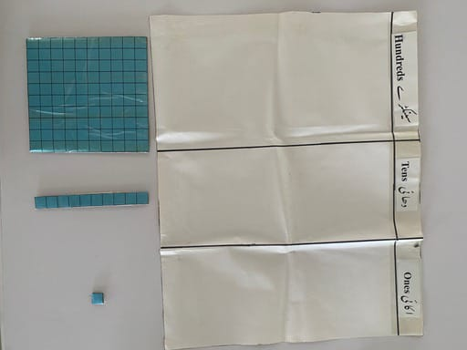

ONES 2D BLOCKS (Cut the grid to get 1OO PIECES)

|  |  |  |  |  |  |  |  |  |  |
| --- | --- | --- | --- | --- | --- | --- | --- | --- | --- |
|  |  |  |  |  |  |  |  |  |  |
|  |  |  |  |  |  |  |  |  |  |
|  |  |  |  |  |  |  |  |  |  |
|  |  |  |  |  |  |  |  |  |  |
|  |  |  |  |  |  |  |  |  |  |
|  |  |  |  |  |  |  |  |  |  |
|  |  |  |  |  |  |  |  |  |  |
|  |  |  |  |  |  |  |  |  |  |
|  |  |  |  |  |  |  |  |  |  |
|  |  |  |  |  |  |  |  |  |  |

|  |
| --- |
| Hundreds سینکڑا |

TENS 2D BLOCKS (Cut the grid to get 13 PIECES)

|  |  |  |  |  |  |  |  |  |  |
| --- | --- | --- | --- | --- | --- | --- | --- | --- | --- |
|  |  |  |  |  |  |  |  |  |  |
|  |  |  |  |  |  |  |  |  |  |
|  |  |  |  |  |  |  |  |  |  |
|  |  |  |  |  |  |  |  |  |  |
|  |  |  |  |  |  |  |  |  |  |
|  |  |  |  |  |  |  |  |  |  |
|  |  |  |  |  |  |  |  |  |  |
|  |  |  |  |  |  |  |  |  |  |
|  |  |  |  |  |  |  |  |  |  |
|  |  |  |  |  |  |  |  |  |  |

|  |  |  |  |  |  |  |  |  |  |
| --- | --- | --- | --- | --- | --- | --- | --- | --- | --- |
|  |  |  |  |  |  |  |  |  |  |
|  |  |  |  |  |  |  |  |  |  |
|  |  |  |  |  |  |  |  |  |  |

HUNDREDS 2D BLOCK (1 PIECE)

|  |  |  |  |  |  |  |  |  |  |
| --- | --- | --- | --- | --- | --- | --- | --- | --- | --- |
|  |  |  |  |  |  |  |  |  |  |
|  |  |  |  |  |  |  |  |  |  |
|  |  |  |  |  |  |  |  |  |  |
|  |  |  |  |  |  |  |  |  |  |
|  |  |  |  |  |  |  |  |  |  |
|  |  |  |  |  |  |  |  |  |  |
|  |  |  |  |  |  |  |  |  |  |
|  |  |  |  |  |  |  |  |  |  |
|  |  |  |  |  |  |  |  |  |  |
|  |  |  |  |  |  |  |  |  |  |

|  |
| --- |
| Ones اکائی |

HUNDREDS 2D BLOCK (1 PIECE)

|  |  |  |  |  |  |  |  |  |  |
| --- | --- | --- | --- | --- | --- | --- | --- | --- | --- |
|  |  |  |  |  |  |  |  |  |  |
|  |  |  |  |  |  |  |  |  |  |
|  |  |  |  |  |  |  |  |  |  |
|  |  |  |  |  |  |  |  |  |  |
|  |  |  |  |  |  |  |  |  |  |
|  |  |  |  |  |  |  |  |  |  |
|  |  |  |  |  |  |  |  |  |  |
|  |  |  |  |  |  |  |  |  |  |
|  |  |  |  |  |  |  |  |  |  |
|  |  |  |  |  |  |  |  |  |  |

|  |
| --- |
| Tens دہائی |