**TEN FRAME CARDS**

|  |  |
| --- | --- |
| **Manipulative** | **Ten Frames Cards** |
| **Materials** | A4 Paper |
| Scissors |
| Glue |
| Tape |
| 260 grams Card Sheets |
| **Details of 1 set** | 1 set of 20 cards in total (10 cards representing counts from 0 to 9 and 10 cards representing 10) |

**Guidelines:**

1. Print the design file on white paper.
2. Cut out each ten-frame along the scissors sign (2 by 5 for each number).
3. Cut out 4.5 by 6 inches rectangular sections from the card sheets.
4. Paste the ten-frame cutouts on the center of each rectangular card sheet.
5. Cut out the individual number boxes.
6. Paste two number boxes, showing the same number, one on the upper right corner and one on the bottom left corner of the rectangular card sheet.
7. Wrap full rectangular card sheet in tape.

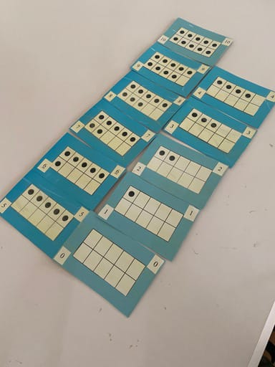



|  |  |  |  |  |  |  |  |  |  |
| --- | --- | --- | --- | --- | --- | --- | --- | --- | --- |
|  |  |  |  |  |  |  |  |  |  |
|  |  |  |  |  |  |  |  |  |  |
|  |  |  |  |  |  |  |  |  |  |
|  |  |  |  |  |  |  |  |  |  |
|  |  |  |  |  |  |  |  |  |  |
|  |  |  |  |  |  |  |  |  |  |







|  |  |  |  |  |  |  |  |  |  |
| --- | --- | --- | --- | --- | --- | --- | --- | --- | --- |
|  |  |  |  |  |  |  |  |  |  |
|  |  |  |  |  |  |  |  |  |  |
|  |  |  |  |  |  |  |  |  |  |
|  |  |  |  |  |  |  |  |  |  |
|  |  |  |  |  |  |  |  |  |  |
|  |  |  |  |  |  |  |  |  |  |







|  |  |  |  |  |  |  |  |  |  |
| --- | --- | --- | --- | --- | --- | --- | --- | --- | --- |
|  |  |  |  |  |  |  |  |  |  |
|  |  |  |  |  |  |  |  |  |  |
|  |  |  |  |  |  |  |  |  |  |
|  |  |  |  |  |  |  |  |  |  |
|  |  |  |  |  |  |  |  |  |  |
|  |  |  |  |  |  |  |  |  |  |







|  |  |  |  |  |  |  |  |  |  |
| --- | --- | --- | --- | --- | --- | --- | --- | --- | --- |
|  |  |  |  |  |  |  |  |  |  |
|  |  |  |  |  |  |  |  |  |  |

|  |  |  |  |  |  |  |  |  |  |  |  |  |  |
| --- | --- | --- | --- | --- | --- | --- | --- | --- | --- | --- | --- | --- | --- |
| 0 | 0 | 1 | 1 | 2 | 2 | 3 | 3 | 4 | 4 | 5 | 5 | 6 | 6 |
| 7 | 7 | 8 | 8 | 9 | 9 | 10 | 10 | 10 | 10 | 10 | 10 | 10 | 10 |
| 10 | 10 | 10 | 10 | 10 | 10 | 10 | 10 | 10 | 10 | 10 | 10 | 10 | 10 |